**Topcoder - Implement Endpoint To Populate Elasticsearch For The Given Challenges**

# 

# Setup

For the challenge feeder service, run 'mvn clean package' to compile the code and then cd local folder and run './run.sh' to start the services. Before starting the services, you need to first setup the envrionment as following sections.

Change the port elasticsearch-feeder-service.yaml if direct-app is already running the 8080 port.

If you want to push the challenge to the amazon elasticsearch service, configure the

the local/run.sh as:

#export ELASTIC_SEARCH_URL="http://$DOCKER_IP:9200"

export ELASTIC_SEARCH_URL="https://search-your-url-xxxxx.us-east-1.es.amazonaws.com"

export CHALLENGES_INDEX_NAME="challenges"

export AWS_SIGNING_ENABLED=false

export AWS_REGION=us-east-1

export ASW_SERVICE=es

export AWS_ACCESS_KEY=your key here

export AWS_SECRET_KEY=your secret here

You should create the domain at https://aws.amazon.com/cn/elasticsearch-service/.

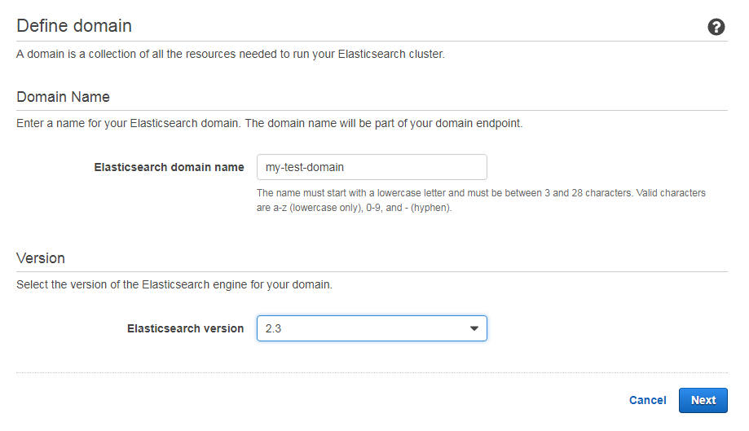

When you are setting up access policy there are many options.

For example if you choose **Allow or deny access to one or more AWS or IAM users**.

You must configure **AWS_ACCESS_KEY**, **AWS_SECRET_KEY**, **AWS_SERVICE**, and  **AWS_REGION** in local/run.sh, and set **AWS_SIGNING_ENABLED** as true.

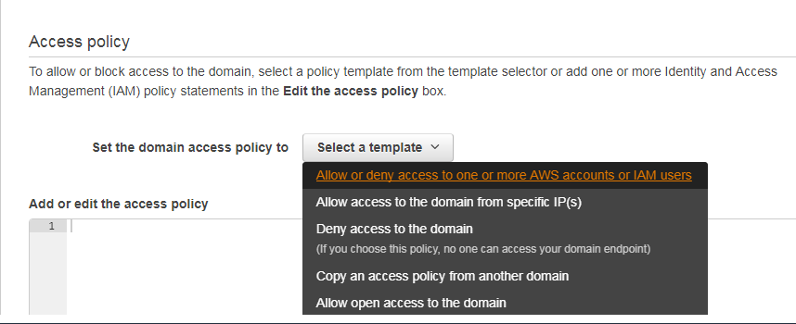

If you chose 'Allow open access to the domain', set AWS_SIGNING_ENABLED to false to disable the credential. Please been noted that this should be just for test purpose.

After you wait about 10 minutes to create domain successfully you can configure **ELASTIC_SEARCH_URL** to the endpoint below:

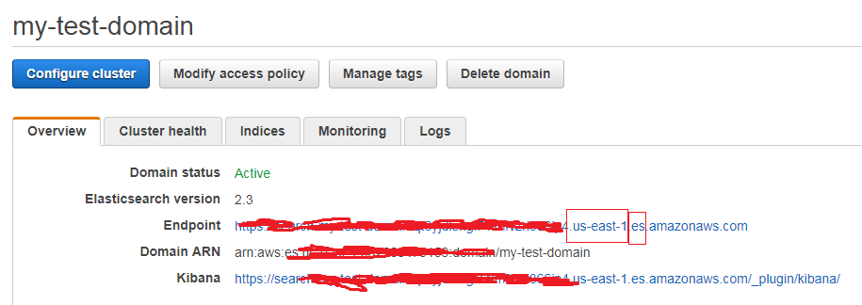

The **AWS_REGION** is us-east-1 and the **AWS_SERVICE** is es.

The direct app docker is https://github.com/appirio-tech/tc-common-tutorials/tree/master/docker/direct-app

# Verify

Import the docs/ Implement Endpoint To Populate Elasticsearch For The Given Challenges.postman_collection.json

create new challenges using the direct app and note down the challenge id

Push challenges created above with below postman script.

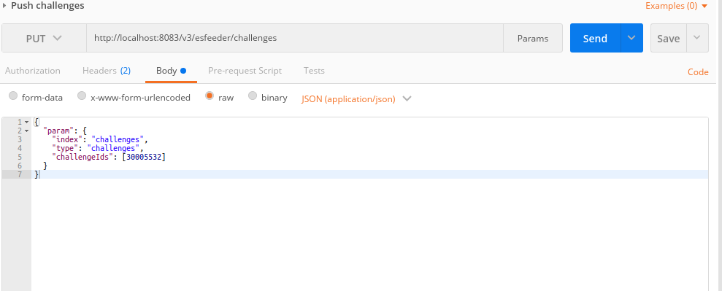

View challenge details via ElasticSearch

Change the challenge id in and elastic search URL in the postman script

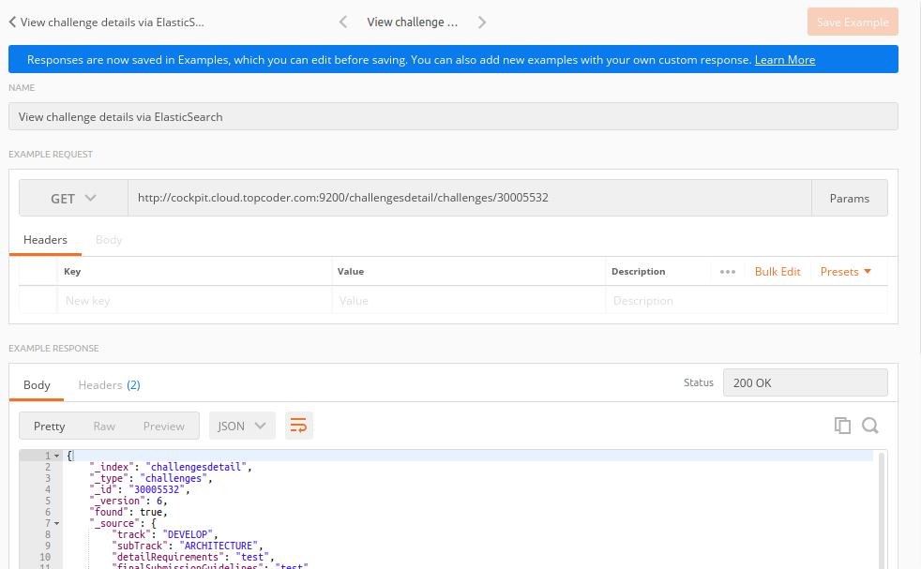

View challenge listing data using the View challenge listing via ElasticSearch postman script.

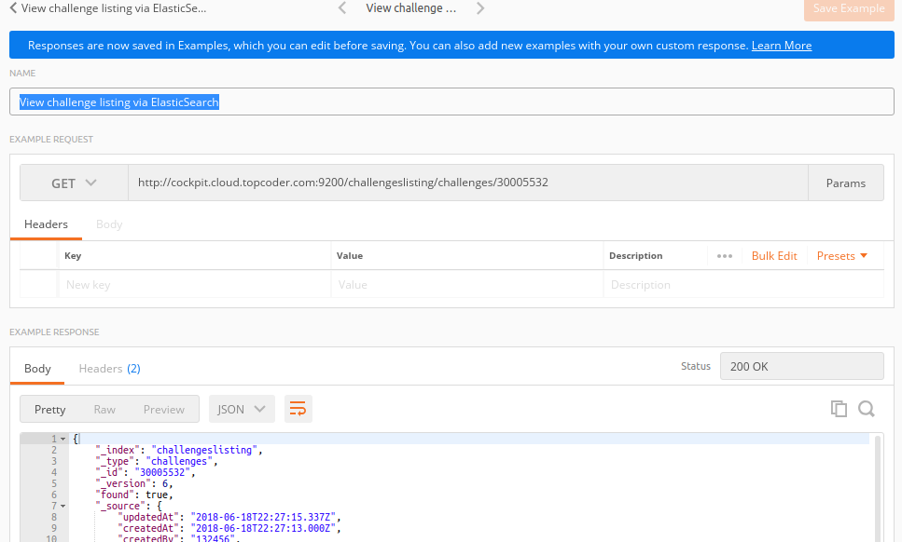Repeat the verification step by updating the above created challenge id using direct app and verify the details are updated in elastic search too.